A Retrospective Analysis: Exploring the Historical
Progress of AI devices in Healthcare

Sagar Balwani | Katchhi Ziya-ul Rahman |  | Rishabh Bhansali
sagarbalwani1@gmail.com | rahmankatchhi48@gmail.com |  | jainr3026@gmail.com
CSA-ITM (SLS) BU | CSA-ITM (SLS) BU |  | CSA-ITM (SLS) BU
Gujarat, India | Gujarat, India |  | Gujarat, India
Nidhi Sompura |  | Dr. Jonita Roman
nidhisompura999@gmail.com |  | jonita.roman@itmbu.ac.in
CSA-ITM (SLS) BU |  | CSA-ITM (SLS) BU
Gujarat, India |  | Gujarat, India

Abstract—Artificial Intelligence (AI) has played a major role in the evolution of medical and healthcare practice. It has developed various devices which are used by physicians and medical practitioners for detecting, diagnosing, treating and predicting the spread of disease. It has reduced the cost of hiring various physicians for their diagnosis as well as increased the accuracy of the same. This study explores implications and development of AI in Healthcare Management with the help of other review and research papers that have used AI models in different sectors of healthcare.
Keywords—Artificial Intelligence(AI), Healthcare, Diagnosis, Management

Introduction
Artificial Intelligence(AI) can be generally referred to as the technology that emulates mechanisms assisted by human intelligence, such as deep learning, adaptation, prediction and much more [2]. AI still hasn’t built the capability of completely replacing humans, but can assist physicians to achieve better and accurate results [1]. The evolution of AI in the medical field and healthcare dates back in the early 1950s and 1940s, where physicians made first attempts in improving their diagnoses using computer-aided programs [2, 3]. AI was initially based on conditional methods, or ‘if-then-else rules’ [3]. Our paper will concentrate on AI devices that have been helping physicians and other practitioners in healthcare over the past few decades and their rapid evolution..

Origin of AI in Healthcare

The word "Artificial Intelligence" was first coined in a Dartmouth College conference proposal in 1955. But the AI applications did not penetrate the healthcare area until the early 1970s when research generated MYCIN, an AI algorithm that helped find blood infections. The spread of AI research continued, and in 1979 the American Association for Artificial Intelligence was created (now the Association for the Advancement of Artificial Intelligence, AAAI).

Throughout the 1980s and 1990s, the construction of new AI systems helped accomplish medical achievements such as:

- Producing speedier data collecting and processing
- Assisting in more accurate surgical procedures
- In-depth DBA research and mapping
- More widespread implementation of electronic health records

AI technology and machine intelligence have evolved to influence how healthcare is delivered significantly. This advanced technology has evolved beyond biological sciences, where it began and now applies to medical specializations, including:

- Radiology
- Screening
- Psychiatry Primary Care Disease Diagnosis
- Telemedicine

Significant progress has been made in AI Technology for Medical and Healthcare over past decades. Diagnostic, Therapy, Monitoring and Patient Care have all undergone Radical Changes as a result of these gadgets.

ABBREVATIONS
AI – Artificial Intelligence
AAAI – Association for the Advancement of Artificial Intelligence
DBA – Data Base Administrator
MRI – Magnetic Resonance Imaging
CT – Computed Tomography
CAD – Computer-Aided Design
ANN – Artificial Neural Networks
LIDC – Lung Image Database Consortium
NCI – National Cancer Institute
FNIH – The Foundation for the National Institute of Health

Rise of Artificial Intelligence in Healthcare
Artificial Intelligence plays a significant role in our day-to-day lives [4]. The evolution of AI devices in the field of medical and healthcare has been transformative, revolutionising the way we approach diagnosis, treatment, and patient care. In the early stages, AI devices in medicine primarily focused on pattern recognition and data analysis. They were designed to assist healthcare professionals in interpreting medical images such as X-rays, CT scans, and MRIs, helping to identify potential abnormalities or diseases. These systems greatly improved diagnostic accuracy and efficiency, enabling doctors to make more informed decisions. Some of the devices that have significantly helped in the field of medical and healthcare are listed below:

Bionic Eyes
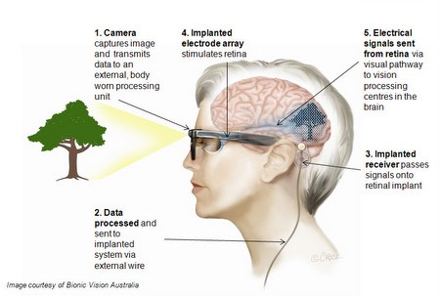
Attempts have been made for over a century to restore human vision to individuals. However, it wasn’t possible until 1929 when a German scientist, George von Bekesy, conducted the first successful experiment to restore vision using electrical simulation. He used electrical currents for stimulating the optic nerves of blind patients, which resulted in patients seeing light flashes. Using this, a team of researchers led by William Dobelle developed the first successful retina implant in 1968. Bionic eyes of Visual Prostheses are the devices designed to restore visions to individuals with visual impairments [4]. A classical approach of bionic eyes has been illustrated in the figure below.

Artificial Neuron
In 1943, McCulloch and Pitts set the mathematical foundations for a tool that attempted to emulate the human brain [3]. The proposed a computational model known as McCulloch-Pitts (M-P) neuron, which served as a simplified representation of biological neuron. The M-P neuron took binary inputs and produced a binary output based on predefined thresholds and logical operations. It was later known as the artificial neuron. Fifteen years later, Frank Rosenblatt (an American Psychologist), presented the perceptron, an artificial neuron model capable of learning. It was designed to mimic the basic functionality of a biological neuron and was able to learn simple patterns.

MYCIN
MYCIN is an early computer program developed in the 1970s at Stanford University. It was one of the first expert systems designed to assist in medical diagnosis and treatment recommendation for diseases such as blood infections. Mycin was created by Edward Shortliffe, a medical student at the time, as part of his research in computer-based medical decision-making. MYCIN would attempt to diagnose patients based on reported symptoms and medical test results [3]. The program could request further information concerning the patient, as well as suggest additional laboratory tests, to arrive at a probable diagnosis, after which it would recommend a treatment.

CADx
CADx (Computer-Aided Diagnosis) was invented in the 1990s by researchers who were exploring the use of artificial neural networks (ANN) for medical image analysis. A perceptron is an effort to emulate the way the human brain functions and ANN can be considered as the generalized form of the simple perceptron idea, it's like having multiple perceptrons [5]. The CADx system for breast cancer detection was developed in 1994 by a team of researchers at the University of Chicago, and it used artificial neural networks to analyze mammograms and radiologists detect and diagnose breast cancer, later on they continue to be an active area of research in medical imaging and artificial intelligence. CAD systems can be very cost-effective, especially if a disease is detected at an early stage and it is treated before it progresses to advanced stages [5]. A general architecture of the working of CAD systems can be represented in the figure below.
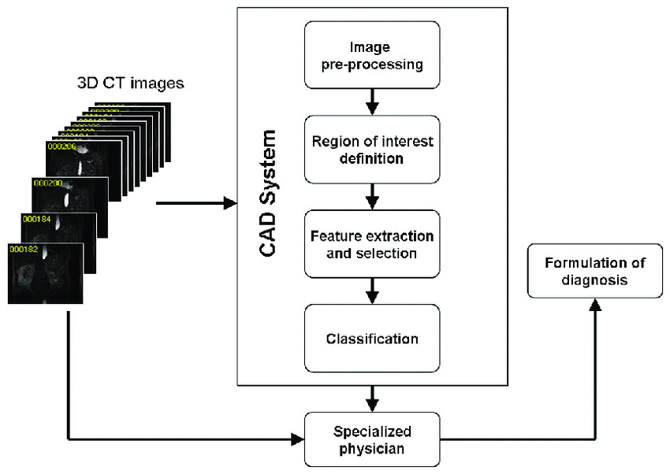

- LIDC (Lung Image Database Consortium)
The history of the Lung Image Database Consortium can be traced back to the early 2000s when lung cancer became a major public health concern due to its high mortality rate and the challenges associated with its early detection. At that time, advancements in medical imaging technology, particularly computed tomography (CT) scans, were offering new opportunities for the early detection and diagnosis of lung cancer. However, CT scans were highly dependent on the expertise radiologists and was experiencing lack of standardized criteria. Recognizing these challenges, the National Cancer Institute (NCI) and the Foundation for the National Institutes of Health (FNIH) initiated the LIDC project in 2002. The LIDC brought together a consortium of academic institutions, medical centers, and industry partners to create a publicly accessible database of lung images and associated clinical data [6]. LIDC used computer vision algorithms to analyze the scans and identify suspicious nodules that could be cancerous. It typically occurs in older patients with a history of tobacco use (median age at diagnosis of 70 years). By the time of diagnosis, more than 50% of patients with lung cancer already have a metastatic disease, so the LUNG IMAGE DATABASE CONSORTIUM was designed to detect lung cancer.

Wearable Devices
Developing wearable devices and algorithms to monitor mental conditions is a relatively new domain in the field of AI. Some wearable devices are equipped with sensors that can detect human physiology status, such as heartbeat, blood pressure, body temperature, or other complex vital signs (e.g. electrocardiograms). Using these signals, new systems can be developed to monitor mental conditions. Tracking physical activities using wearable devices has become a popular method to help people assess activity intensity and calories expended. There is a growing interest among health consumers to use wearable devices, especially consumer wearable devices, to track weight control activities and outcomes.

A study by Dooley, Golaszewski, & Bartholomew (2017) compared and validated three major consumer devices for measuring exercise intensities. The study devices included Fitbit Charge HR, Apple Watch, and Garmin Forerunner 225. The project enrolled 62 participants aged 18-38 and measured their heart rates and energy expenditures using all three devices. A hypothetical ideal "gold standard" test had a sensitivity of 100% and a specificity of 100%. The study showed a high magnitude of errors across all devices when compared to the gold standard. This study indicated that these devices might be useful as a stimulus to increase activity, but they have limitations as a tracking and outcome measurement method [9].
Wearable devices have great potential to be used in fall prevention among older adults. Falls occur in 30% to 60% of older adults each year, and 10% to 20% result in injury, hospitalization or death. For the elderly people in the USA, falls lead to four to 12 days of hospital stay per fall. Recent studies have focused on developing wearable devices and associated algorithms to collect and analyze gait (manner of walking) data for fall prevention [9].
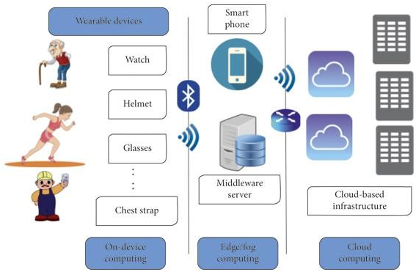
The general working mechanism of wearable devices can be illustrated in the below figure.

Blood Sugar Levels Analyzer
There have been many AI tools developed for analyzing blood sugar levels and helping people manage diabetes. FreeStyle Libre, which was developed by Abbott Laboratories and uses a small sensor attached to the skin to measure glucose levels continuously. The system’s disposable sensor is applied to the back of a patient’s arm and can be worn for 10 days with the personal device and up to 14 days with the Pro version. The device can then use algorithms to provide real-time insights and alerts to users. The device was not always accurate and eventually discontinued due to safety concerns. The sensor does not need to be calibrated with blood glucose meter readings to maintain accuracy. Freestyle Libre allows valuable glucose data to be collected even if patients are inconsistent with their blood glucose monitoring [8]. However, despite the advantages, it can be harmful and is not recommended for children < 18 years of age or for patients who are pregnant. The below image shows the use and working of this FreeStyle Libre Patches.

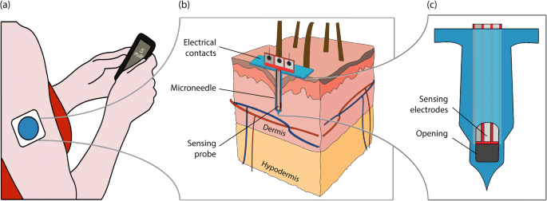
Another example is the GLUCOWATCH, which was developed by Cygnus Inc. in the early 2000s and used a biosensor to measure glucose levels in interstitial fluid [7]. GlucoWatch biographer provides automatic, frequent and noninvasive blood glucose measurements for up to 12 h. The device extracts glucose through intact skin where it is measured by an amperometric biosensor. The device could then use AI algorithms to predict blood glucose levels and alert users if their levels were too high or too low [7]. This has been considered as a safe and effective method to track glucose level trends and patterns, which should enable improved glycaemic control for many patients. A working representation of this watch is illustrated in the below figure.

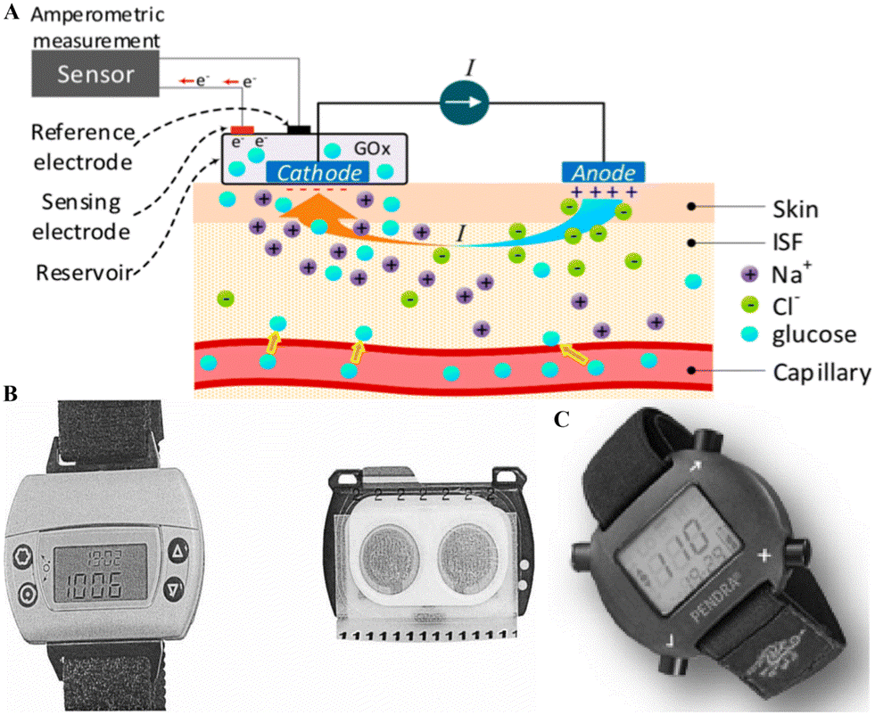

Chatbots
Chatbots, as part of AI devices, are natural language processing systems acting as a virtual conversational agent mimicking human interactions. While this technology is still in its developmental phase, health chatbots could potentially increase access to healthcare, improve doctor–patient and clinic–patient communication, or help to manage the increasing demand for health services such as via remote testing, medication adherence monitoring or teleconsultations. The chatbot technology allows for such activities as specific health surveys, setting up personal health-related reminders, communication with clinical teams, booking appointments, retrieving and analyzing health data or the translation of diagnostic patterns taking into account behavioral indicators such as physical activity, sleep or nutrition [10]. Chatbots in medical and healthcare initially emerged as simple information retrieval systems. They were designed to provide basic responses to frequently asked questions and offer general health advice. Chatbots offer round-the-clock availability, allowing patients to seek guidance or support at any time. This is particularly useful in emergencies or situations where immediate medical advice is needed. They are equipped with AI algorithms that can assist healthcare professionals by providing evidence-based recommendations for diagnosis and treatment plans. They can analyze medical literature and patient data to support decision-making. They can follow up with patients after hospital discharge, ensuring adherence to treatment plans, monitoring recovery progress, and addressing any concerns or questions. An Example of a chatbot symbolizing how it can be useful in our day-to-day lives and how it can provide guidance for basic to severe health problems.

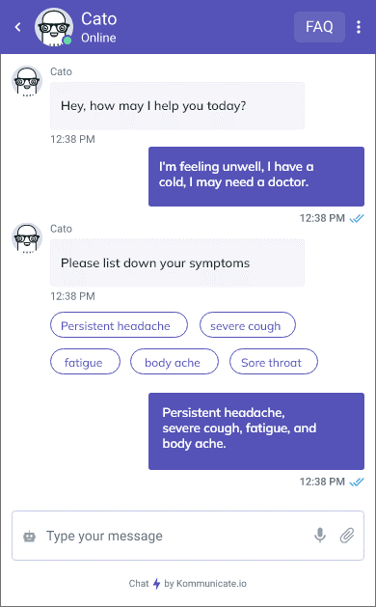

Conclusion

In conclusion, the integration of artificial intelligence (AI) and wearable devices has ushered in a new era of revolution in the healthcare sector. This powerful combination has shown immense potential in transforming patient care, disease management, and healthcare delivery.

AI algorithms have proven to be highly effective in analyzing vast amounts of medical data generated by wearable devices. These devices, such as smartwatches, fitness trackers, and biosensors, have become ubiquitous, capturing real-time physiological data and providing continuous monitoring capabilities. Through advanced machine learning techniques, AI can quickly and accurately detect patterns, anomalies, and trends in these data, leading to early detection of diseases, timely interventions, and improved patient outcomes.

Wearable devices equipped with AI-powered algorithms have brought personalized healthcare to the forefront. They enable continuous monitoring of vital signs, sleep patterns, physical activity levels, and other health metrics. With real-time feedback and actionable insights, individuals can actively engage in self-care, make informed lifestyle choices, and manage chronic conditions more effectively. This empowers patients to take a proactive role in their own health, reducing the burden on healthcare systems and promoting overall well-being.

Furthermore, AI in combination with wearable devices has enhanced remote patient monitoring, especially in underserved areas and during emergencies. Patients can transmit data to healthcare professionals in real-time, allowing for prompt diagnosis, remote consultations, and timely interventions. This has proved invaluable in critical situations, improving the quality and efficiency of healthcare delivery while reducing costs and unnecessary hospital visits.

Moreover, the utilization of AI and wearable devices in healthcare research has led to groundbreaking advancements. Large-scale data collected from wearables can be aggregated and anonymized, enabling researchers to gain insights into population health trends, disease patterns, and treatment outcomes. This has the potential to fuel discoveries, improve clinical trials, and accelerate the development of personalized medicine, ultimately revolutionizing healthcare practices on a global scale.

Despite these remarkable advancements, challenges remain. Privacy and data security concerns need to be addressed to ensure trust and safeguard patient information. Regulatory frameworks must adapt to keep pace with the rapid evolution of AI technologies. Interoperability standards and data integration across various devices and platforms are essential for seamless integration and maximum benefit.

In conclusion, the synergy between AI and wearable devices has revolutionized the healthcare sector by enhancing patient care, enabling proactive health management, facilitating remote monitoring, and advancing medical research. As we continue to harness the power of AI and wearable technology, we can look forward to a future where healthcare is more precise, accessible, and personalised, ultimately improving the well-being of individuals and transforming the healthcare landscape as a whole

References
- Manne, Ravi, and Sneha C. Kantheti. 2023. “Application of Artificial Intelligence in Healthcare: Chances and Challenges.” SSRN. https://ssrn.com/abstract=4393347

- Secinaro, Silvana, Davide Calandra, Aurelio Secinaro, Vivek Muthurangu, and Paolo Biancone. 2021. “The role of artificial intelligence in healthcare: a structured literature review.” BMC Medical Informatics and Decision Making. https://rdcu.be/ddH0I

- Greenhill, Alexandra T., Nasim Parsa, Ulas Bagci, Michael F. Byrne, Daljeet Chahal, and Omer Ahmad, eds. 2023. AI in Clinical Medicine: A Practical Guide for Healthcare Professionals. N.p.: John Wiley & Sons, Incorporated.

- Joshi, Amit, and Ramaswamy H. Sarma. 2023. “(PDF) A Review on Applications of Artificial Intelligence on Bionic Eye Designing and Functioning.” ResearchGate. https://www.researchgate.net/publication/370188182 A_Review_on_Applications_of_Artificial_Intelligence_on_Bionic_Eye_Designing_and_Functioning.

- Yanase, Juri, and Evangelos Triantaphyllou. 2019. “A systematic survey of computer-aided diagnosis in medicine: Past and present developments.” ScienceDirect. https://doi.org/10.1016/j.eswa.2019.112821

- Armato III, Samuel G., Geoffrey McLennan, Luc Bidaut, and Charles R. Meyer. 2011. “The Lung Image Database Consortium (LIDC) and Image Database Resource Initiative (IDRI): A Completed Reference Database of Lung Nodules on CT Scans.” American Association of Physicists in Medicine. https://doi.org/10.1118/1.3528204

- Tierney, Michael J., Janet A. Tamada, Russell O. Potts, Richard C. Eastman, Kenneth Pitzer, Neil R. Ackerman, and Steven J. Fermi. 2010. “The GlucoWatch biographer: a frequent, automatic and noninvasive glucose monitor.” Taylor and Francis Online. https://doi.org/10.3109/07853890009002034

- Blum, Alyson. 2018. “Freestyle Libre Glucose Monitoring System.” ClinicalDiabetes. https://doi.org/10.2337/cd17-0130

- Wu, Min, and Jake Luo. 2019. “Wearable Technology Applications in Healthcare: A Literature Review.” HIMSS.
https://www.himss.org/resources/wearable-technology-applications-healthcare-literature-review

- Nadarzynski, Tom, Oliver Miles, Aimee Cowie, and Damien Ridge. 2019. “Acceptability of artificial intelligence (AI)-led chatbot services in healthcare: A mixed-methods study.” Sage Journals. https://journals.sagepub.com/doi/10.1177/2055207619871808

